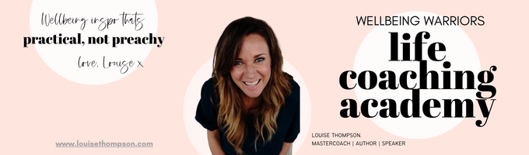
~ CONNECTION WITH INTENTION ~
Worksheet: Connection Inventory
June 2026

“Connection is why we are here” – Brene Brown

This is kinda a big worksheet! Write as little or as much as you like and see what comes to the surface for you – I think you will find it very revealing. Your inspiration is the above quote from Brene Brown…enjoy!

Section 1:
What do you think you might like more of in terms of connection? Just off the top of your head? What would be a good addition to your life?

Section 2:
Who are you connecting with in this current chapter of life? Connection waxes and wanes in the different chapters of life – it is a moveable flow not a constant, where does it sit for you right now:

Who could you call in need at 2am and you know they would be there for you?

What are your deepest connections? What makes them like that?

Are there any relationships you have that you would appreciate being more connected?

Where do you feel you give a lot in connection but do not get a lot in return?

Who do you love to spend time with? Who does time fly with?

Who notices you? Who makes you feel seen?

What relationships are you the most grateful for? Why?

What lower-level social interactions do you enjoy? Who? When?

What lower-level social interactions do you not really enjoy? Who? When?

Most valuable connections offline?

Most valuable connections online?

What are you most grateful for in terms of the connections you already have in your life?

Section 3:
Making space for intentional connection. Do you need to free up some capacity for connection? Are there some relationships you want to reduce investment in or farewell? Or some circles where you invest a lot of connection time (maybe 5000 ambient connections you scroll through), but you do not get a lot of genuine connection return?

Section 4:
Honour your personality needs when it comes to connection! Some people are wired to energise from a lot of people contact and relish and enjoy a lot of verbal communication. Others genuinely do not require so much (and are genuinely overwhelmed with a lot of people's time) and find solitude or quiet companionship nourishing and replenishing. There is no right or wrong here, this is the ultimate you do you!

How much connection time feels best for you? What feels like too little? What feels like too much?

Is there a time in your life that felt better or worse in terms of connection breadth or depth? How so?

Section 5:
What categories* would you like more or less of (or you are just right, Goldilocks style!) in this chapter of your life with your current capacity. How many in each space? What’s working? What might be better? Online does count.

Intimate connections: super close family/friends.

Close connections: good friends who would come to your house for dinner or you would go do an activity with.

Good connections: people you might invite to your birthday party, or you might chat to casually on the street or at an event.

Visible network: people in your widest circle of connection.

*Feel free to play with or add to these groupings to make them suit your life.

Section 6:
Observations and a little bit of Law Of Attraction magic!
What have you noticed as you have done this inventory of connection in this chapter of your life? What themes are popping up? What have you noticed? Think about breadth of relationships, as well as depth of relationships. Think about your time, energy and attention investments.

And what connections would really enhance your life going forward? Either in terms of enhanced depth of existing relationship, or new relationships of any depth coming into your life. What would you love to see happen in this space in your life?

Good work you! Connection as Brene Brown says “why we are here” so to spend some time doing a stock take of where we are at and where we would like to go is very valuable time invested indeed.

