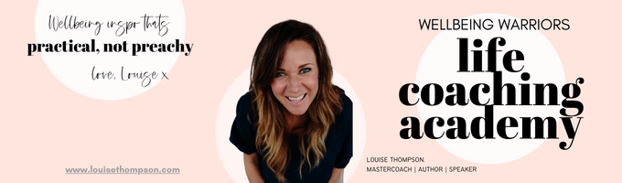
~ Complaint Crushing ~ Worksheet 2 - May 2026

Use this whenever you are moaning about something.
Get it OUT OF YOUR HEAD AND ONTO PAPER!

What’s the problem? What am I not happy about? BE SPECIFIC. Define in 3 sentences OR LESS.

How long have I been complaining about this? How often? To who? Myself or others, or both? Be specific.

How important is this complaint situation? On a scale of 1 to 10 in my life? Zoom out 5 years: how important is this thing?

Have I addressed this situation DIRECTLY with the person or organisation responsible?

If yes, detail exactly how I went about this? How did I frame the conversation? How did I define the solution/outcome I was seeking? Did I get their buy in to a solution focus upfront?

How did it go? What was the outcome?

What do I want to do now? 4 options to think through:

- Have a courageous conversation about a solution to this complaint? If so, what is the solution I am seeking? Define WHO EXACTLY I need to talk with to obtain a solution. Define it here in 3 sentences OR LESS. Be SPECIFIC.

WHO I need to have a Courageous Conversation with is __________________

The OUTCOME I would like to this situation is ___________________________

Or do I want to:

- Leave the situation causing this complaint? Having considered it, I am done and my most peaceful choice is to walk away. Detail my conclusion here:

- Pack lighter about this complaint? How can I feel better about this situation simply by telling myself a better feeling - truer? – story? Define it here (especially good when you realise this really is a pretty inconsequential complaint*).

* Note – you can dive into the Packing Lighter module in the WW Library - https://iamawellbeingwarrior.com/course/module-70-packing-light-revisited-september-2021/

- Extend grace and acceptance to this situation? It is not that big of a deal when you stop and consider? Are they doing the best they can? Am I? Do I really want to invest more energy into this complaint? Is extending grace my most peaceful choice here? Extend some grace and move on with my life?

GREAT JOB! How long had that complaint been going round in your head?! So much better on paper. What have you learned from dissecting your complaint today?

