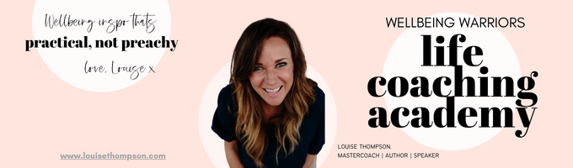
Dream It: Do It
Worksheet

This is THE BEST worksheet!
Go make yourself a cuppa. Dive in. Enjoy the process 😊

It’s the morning of Christmas Eve-Eve, Wednesday December 23rd 2026 and I’ve reached today feeling _____________________, and _________________. I’ve just had one of those secret miracle cancellations of a “we must catch up before Christmas!” coffee meetings I secretly wasn’t that bothered about and happily found myself with a spare hour in this gorgeous little café on my own with my favourite ___________________ already ordered and on its way! WOOP! Mmmm. I’ve got my laptop / journal / back of an old envelope and a pen with me…do you know what? I am going to take a moment to review my 2026, right here, right now. I am a Wellbeing Warrior, I LOVE doing this stuff!

Overall, I feel pretty ___________________ about 2026, the things I am most proud and pleased about is that I _____________________________. I am also really glad that I resolved ______________________________. My happiest moment this year was shared with ____________________________ and it was so special.

When I break it down a little, WW style, it’s very cool to look at the accomplishments and highlights I’ve made in each area of life this year, some are small wins, some are bigger - it’s a good balance. Well done me!

In terms of mental health and personal growth I am really pleased I was consistent about _______________________________________ as that has made a real difference to____________________. The other big win in this area was ____________________________________________. When it comes to the key relationships in my life, specifically with _____________________ the best thing we have done/created/discussed/progressed/experienced this year was _____________________________ and I am SO glad I/we made the time to make that happen.

In terms of my house/living situation I feel ___________________ about how I’ve managed _________________ this year! The highlight was definitely ____________________________________________.

Body-wise, my physical health this year has really benefitted from the decision I took to consistently look after myself by _______________________ and doing that _____________________. I am also SO proud of myself for not just starting but continuing the habit of ________________________ in 2026: biiiiig win! I have learned __________________________ about myself from a year of keeping my word to myself and my body.

I am also super proud of how ______________________________ has unfolded in my career/job/retirement, directly linked to my decision to ________________________. Money has been _____________________ this year and I feel __________________________ about it due to __________________________.

Socially __________________________________ was brilliant for me, and my favourite pastime/hobby/holiday/event of the year was undoubtedly _______________________________. I am So glad I decided to __________________________________________________________. In terms of friends and family I am super pleased I diarised the time to do _________________ with ________________ this year, and that I also had great experiences/connections with _______________, _______________ and _____________________.

This year I am especially grateful for ___________________________ and that ______________________ worked out. I am also feeling peaceful about ________________________ and that I can gently farewell _________________: it’s time to let that go.

I am proudest of myself in terms of ________________________ and I have learned so much about _______________________ this year. I am a woman who _________________________.

To sum up am so glad I invested time and prioritised ____________________ in 2026, that has really made a difference to my life. The happiest moment of the whole damn year was _________________________, and the whole year has been filled with much joy and connection. If 2026 has been this good I can’t wait to see what 2027 has in store!

I am going to finish this delicious________________ in this café, and go have a ______________________ Christmas! What a year to review, super pleased with myself: 2026 has been a ________________ year. Being so INTENTIONAL about who/how/where I invested my time/energy/attention/money has created the most wonderful year jam packed with ___________________________________. Bring on this beautiful Christmas about to unfold, and a whole new year for me intentionally fill in 2027!

