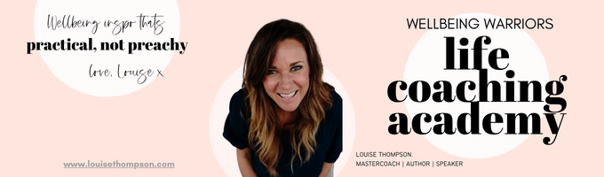
~ Liver Lover ~ March 2025
The Liver Wellness Quiz: Self-Check Your Liver’s Health

This quiz is designed to help you assess the current health of your liver by identifying potential symptoms of an overworked liver that you might not even realise are liver-related.

By answering the questions below, you’ll gain valuable insights into which symptoms could be linked to liver function.

Remember, your liver has over 500 different functions in your body, and if you’ve never given your liver a proper REST, I highly recommend an annual RESET to help you THRIVE, not just SURVIVE.

Do you have pain between your shoulder blades? | Y | N
Do you feel sick after eating greasy foods or feel better not eating things like coconut yoghurt? | Y | N
Do your poos float in the toilet bowl? | Y | N
Do you get motion sickness? | Y | N
When pregnant did you get morning sickness? | Y | N
Do you get nausea? | Y | N
Does your skin easily flake? | Y | N
Do you get headaches often? | Y | N
Do you get migraines? | Y | N
Do you get dry skin? | Y | N
Have you had your gallbladder removed? | Y | N
Easily intoxicated if you drink wine? | Y | N
Sensitive to chemicals (perfume, cleaning agents)? | Y | N
History of long use of prescription drugs? | Y | N
Sensitivity to caffeine or alcohol? | Y | N
Do you get headaches when you take a break from coffee? | Y | N
Have you ever done a liver detox/reset before? | Y | N
Do you get Bad breath (Halitosis) – metallic taste in your mouth or a sour taste in your mouth? | Y | N
Do you feel Fatigued after eating- feeling heavy and TIRED! | Y | N
Do you get bloated after eating? | Y | N
Have you been exposed to mould at some point in your life? | Y | N
Do you get sugar cravings throughout the day? | Y | N
Do you find it hard to SWEAT? | Y | N
Are you always needing to snack throughout the day? | Y | N
Do you find you’re highly anxious? | Y | N
Do you get hot flushes? | Y | N
Are your hormones out of balance? | Y | N
Do you get period symptoms? | Y | N
Do you have HIGH cholesterol? | Y | N
Is your vision declining and you're calling it "old age"? | Y | N
Are you eye "whites" not so white! | Y | N
Do you have a strong body odour? | Y | N
Do you have skin problems (acne, red skin, rosacea, red dots on your skin) | Y | N
Do you have unexplained weight gain? | Y | N
Do you have a history of using forever chemicals in your skin, body, hair products? | Y | N
Do you have a history of swimming in chlorinated pools? | Y | N
Do you eat fruit and vegetables from the supermarket? | Y | N

https://shelleygawith.com/

