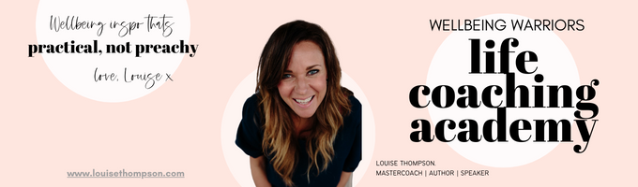

**~ Manifest Your Best ~ Bonus Worksheet - January 2025**

**A Year In Review 2025**

This is THE BEST worksheet!

Go make yourself a cuppa. Dive in. Enjoy the process 😊

It’s the morning of Christmas Eve, Monday December 24th 2025 and I’ve reached today feeling _____________________, and _________________. I’ve just had one of those secret miracle cancellations of a “we must catch up before Christmas!” coffee meetings I secretly wasn’t that bothered about and happily found myself with a spare hour in this gorgeous little café on my own with my favourite _________________ already ordered and on its way! WOOP! Mmmm. I’ve got my laptop / journal / back of an old envelope and a pen with me…do you know what? I am going to take a moment to review my 2025, right here, right now. I am a Wellbeing Warrior, I LOVE doing this stuff!

Overall, I feel pretty ___________________ about 2025, the things I am most proud and pleased of is that I _____________________________. I am also really glad that I resolved ______________________________. My happiest moment this year was shared with ____________________________ and it was so special.

When I break it down a little, WW style, it’s very cool to look at the progress I’ve made in each area of life this year, some are small wins, some are bigger, but it’s a good balance. Well done me!

In terms of mental health and personal growth I am really pleased I _______________________________________ as that has made a real difference to____________________. When it comes to the key relationships in my life, specifically with _____________________ the best thing we have done/created/discussed/progressed/experienced this year was _____________________________ and I am SO glad I made the time to make that happen.

In terms of my house/living situation I feel ___________________ about how I’ve managed _________________ this year! Body-wise, my physical health this year has really benefitted from the decision I took to consistently look after myself by _______________________ and doing that ____________. I am also SO proud of myself for starting the micro-habit of ______________________________ every day: I started Monday January 1st (Mega Monday!) and I have not missed a single day! Biiiiig win! I have learned __________________________ about myself from a year of keeping my word to myself and my body.

I am also super proud of how ______________________________ has unfolded in my career/job/retirement, directly linked to my decision to ________________________. Money has been _____________________ this year and I feel __________________________ about it due to __________________________. Socially __________________________________ was brilliant for me, and my favourite pastime/hobby/holiday/event of the year was undoubtedly _______________________________.

In terms of friends and family I am SO glad I diarised the time to do _________________ with ________________ this year, and that I also had great experiences/connections with _______________, _______________ and _____________________.

This year I am so grateful for ___________________________ and that ______________________ worked out. I am also feeling peaceful about ________________________ and that I can gently farewell _________________: its time to let that go. I am absolutely proudest of ________________________ and I have learned so much about _______________________ this year. I am a woman who _________________________.

I am so glad I invested time and prioritised ____________________ in 2025, that has really made a difference to my life. The happiest moment of the whole damn year was _________________________, and the whole year has been filled with much joy and connection. If 2025 has been this good I can’t wait to see what 2025 has in store!

I am going to finish this delicious ________________ in this café, and go have a ______________________ Christmas! What a year to review, super pleased with myself: 2025 has rocked my socks off! Being so INTENTIONAL about who/how/where I invested my time/energy/attention/finances has created the most wonderful year jam packed with ___________________________________. Bring on this beautiful Christmas about to unfold, and a whole new year for me intentionally fill in 2026!

Write down any other insights or actions that have come to you as you have done this exercise.

| I am so proud of myself for doing 1% more _________________ in 2025, and intentionally doing 1% less _______________________. Small changes that I stuck to that have made a big impact. |
| --- |