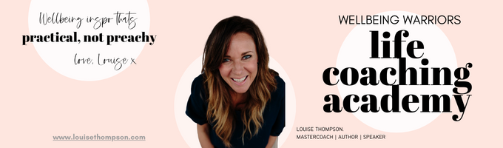

**~ Courage Dear Heart ~ Worksheet 1 - October 2024**

What situation are you currently avoiding dealing with? Try and be as factually accurate as you can.

|  |
| --- |

What are you afraid of? What’s the RISK? Spell it out.

|  |
| --- |

What kind of courage do you need to channel here?

* Physical Courage
* Social Courage
* Moral Courage
* Emotional Courage
* Intellectual Courage
* Spiritual Courage

Can your courage be bigger than your fear?

|  |
| --- |

Detail a time when you were really courageous. What happened? What were your choices? What did you think? What did you do? How did it work out? What were you proud of? What KIND of courage was it?

|  |
| --- |

*Take a moment to really connect with that past display of courage. Know that that always sits within you: she is you. Take three long slow deep breaths.*

What course of action feels like the right one with regard to the situation you described at the top of the worksheet?

|  |
| --- |

*Well done in connecting with your courage.*