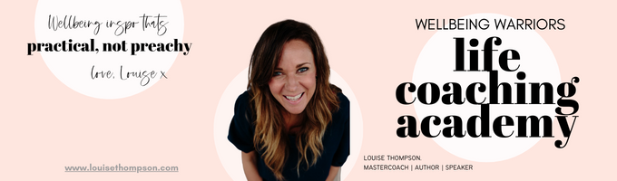

**~ The Body Audit ~ Worksheet 1 - August 2024**

Hey lady! Quick check in right here, right now, to get you in the mindset to start reviewing and actioning your body admin!

What’s good about your health? Where are you and your body doing well?

|  |
| --- |

What could do with work in terms of health admin and body? Where are likely areas of focus?

|  |
| --- |

How often do you get sick? What is it usually? Is there anything recurring or niggly?

|  |
| --- |

| When did you last go to the dentist? |  |
| --- | --- |

| When was your last mammogram? |  |
| --- | --- |

| PAP test / Smear tests? |  |
| --- | --- |

| Eye test? |  |
| --- | --- |

| Mole Map? |  |
| --- | --- |

| Are your vaccinations up to date? |  |
| --- | --- |

**How well (out of 10) do you sleep?**

| **1** | **2** | **3** | **4** | **5** | **6** | **7** | **8** | **9** | **10** |
| --- | --- | --- | --- | --- | --- | --- | --- | --- | --- |

**Libido?**

| **1** | **2** | **3** | **4** | **5** | **6** | **7** | **8** | **9** | **10** |
| --- | --- | --- | --- | --- | --- | --- | --- | --- | --- |

**Mood?**

| **1** | **2** | **3** | **4** | **5** | **6** | **7** | **8** | **9** | **10** |
| --- | --- | --- | --- | --- | --- | --- | --- | --- | --- |

**Energy levels?**

| **1** | **2** | **3** | **4** | **5** | **6** | **7** | **8** | **9** | **10** |
| --- | --- | --- | --- | --- | --- | --- | --- | --- | --- |

**How many days a week do you drink alcohol?**

**1 2 3 4 5 6 7**

Do you take regular medication? How long ago did you review it with your GP?

|  |
| --- |

How much water do you drink? (hahaha) (sorry, long time WW in-joke ) - you can answer! Are you well hydrated on average?

|  |
| --- |

Do you have a minimum baseline for movement? What is it?

|  |
| --- |

How many days a week do you achieve it?

1 2 3 4 5 6 7

Are you in a healthy weight range for your height and build?

|  |
| --- |

How on top of your healthy eating habits are you?

| **1** | **2** | **3** | **4** | **5** | **6** | **7** | **8** | **9** | **10** |
| --- | --- | --- | --- | --- | --- | --- | --- | --- | --- |

Do you take any nutritional or hormonal balance supplements regularly?

|  |
| --- |

What’s your relationship like with your GP?

|  |
| --- |

Health specialists you work with – what for and when did you last see them? Is the issue resolved?

|  |
| --- |

Now you are on a roll are there any other body and health admin items that come to mind for you right now?

|  |
| --- |

*Good work, precious laydee!*

*Doesn’t that feel good to get it all down on paper and see what’s what?!*

*Head on over to the tutorial and let’s get stuck into this month’s teaching and action-taking.*

