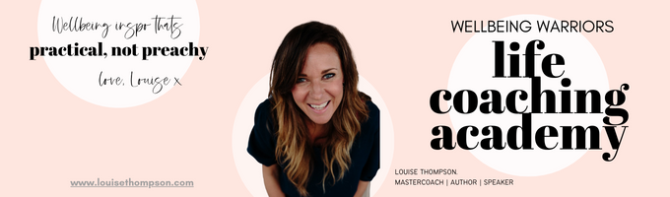

**~ SHRINKING OVERTHINKING ~ Worksheet 2 - July 2024**

**EMPTY YOUR HEAD**

Use this worksheet to Empty Your Head: stressful, circular thoughts do not belong in your head in an endless loop, they belong on paper! Emptying your head is about getting off the overthinking merry-go-round by letting your brain REST. It can safely release all these thoughts as you have them safely captured below. Just START and keep writing til you have no more to say. Each day you do this the easier (and potentially shorter!) it will get.

**What’s really bothering me is…**

**Also….**

**What’s also going round in my head is…**

**Keep going, empty that brain of its overthinking loops! What else is bothering you…**

**And finally this is on my mind…**