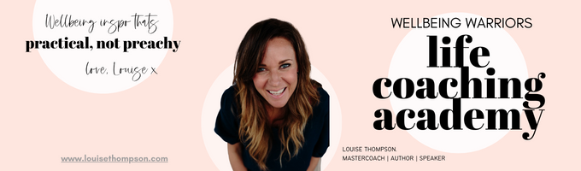
~ Wealth Health ~ Worksheet - April 2023

Big topic: big worksheet! Use this worksheet to start getting clear on your Money Story and your personal Money Beliefs. Make no mistake, both will be shaping your current financial reality in some way. Usually, these things are subconscious and therefore they drive our behaviour and outcomes without us even knowing.

By stepping through this work below you will start bringing them to the surface, where you can consciously evaluate. Decide if they are helping you or limiting you. You can choose to start to shift them if needed to something more abundant and aligned with the wealth health you really want.

Ready? Buckle up. Let’s go.

1. | People with money are...

2. | Money makes people...

3. | I’d have more money if...

4. | My Dad thought money was...

5. | My Mum always thought money would…

6. | In my family, money caused...

7. | Money equals...

8. | If I had money, I’d...

9. | If I could afford it, I’d…

10. | If I had more money, I’d...

11. | I’m afraid that if I had money I would...

12. | Money is…

13. | Money causes…

14. | Having money is not…

15. | In order to have more money, I’d need to...

16. | When I have money, I usually...

17. | I think money...

18. | If I weren’t so tight I’d...

19. | People think money...

20. | Being broke tells me...

21. | What I love about Money is…

22. | The best thing about money is…

23. | Abundance is…

24. | What I’ve learned about money is…

25. | If I could change anything about money in my life I would…

26. | Money is a source of…

in my life.

Next…have a think about your Money Story. We all have one. See if you can piece it together…

My earliest memory of money was…..

When I grew up, In my family money….

One thing I always knew about money was…

As an adult my experience of money is…

What I wish for myself right now in terms of my financial situation is…

Any other memories, thoughts or beliefs about money that are coming to the surface right now are…

The themes I have noticed in my responses are….

Hmmmmmm…..Interesting Mister Bond, yes?
As you work through the module this month you can start to craft a tweaked (or brand new!) money story that takes you in the direction you want to go and is in alignment with your Wealth Health goals.

