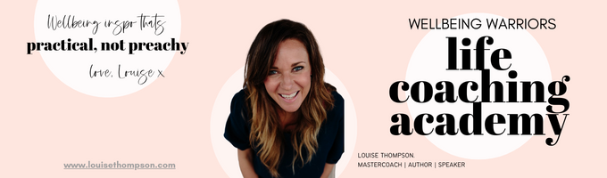
~ Ditch Perfect ~ Worksheet - November 2022

Your worksheet is a super simple way to take a snapshot of where you are at before you dive into the tutorial. This one will only take you a couple of minutes: great prep for the tutorial!

__________________________________________________________________________

Where do you know you expect A LOT (maybe an unreasonable amount?) from yourself?

Where do you know you expect A LOT (maybe an unreasonable amount?) from others?

Where or when do you worry about what other people are thinking of you? Where do you feel you should present a more perfect picture of yourself?

Do people ever say you are “hard on yourself”?

Do certain people or situations bring out the perfectionist in you?

What are your proudest achievements? What do you make them mean about you?

What are your biggest failures? What do you make them mean about you?

Do you tend to think and act in extremes? eg. “I had one biscuit…I might as well have the whole damn packet!”. When?

When do you use the world “should” a lot?

Do you sometimes get fixated on something you messed-up. When? How does that incident feel now you can see it with the perspective of hindsight?

Do you ever procrastinate or not start something, because you might not get it done perfectly?

Do you let yourself make mistakes? Do you put yourself in situations where that’s a possible outcome?

__________________________________________________________________________

Mmmmmmm…much food for thought! Well done on these thought-starters, go dive into the tutorial for your principles and tools!

