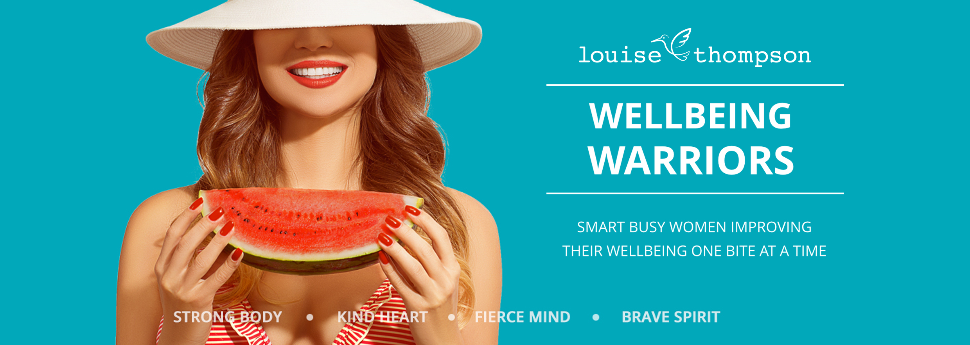
~ Resolution Revolution ~ Worksheet - January 2018

Complete (ideally before you watch the tutorial video) to kick start your healthy habit building work for 2018. Don’t over-think it: whatever your first response is, is perfect!

What New Year Resolutions did you set last January?

- ______________________________________________________________________
- ______________________________________________________________________
- ______________________________________________________________________
- ______________________________________________________________________
- ______________________________________________________________________
- ______________________________________________________________________

What happened? How did you do?

- ______________________________________________________________________
- ______________________________________________________________________
- ______________________________________________________________________
- ______________________________________________________________________
- ______________________________________________________________________
- ______________________________________________________________________

What worked, and why?

What didn’t, and why?

Are there any resolutions you have set over and over again? Or healthy habits you keep trying to establish but not succeeding?

How much willpower do you have?

What healthy habit do you have established already that is easy for you?

When did you establish it and why does it feel easy for you?

Good work, Sugarplum!
Go watch the tutorial and dive into this month’s tools,
and let’s start this ~Resolution Revolution~!

